Royal Academy:
Eco-Visionaries: Confronting a Planet in a State of Emergency

Pinar Yoldas: Eco-system of Excess, 2014
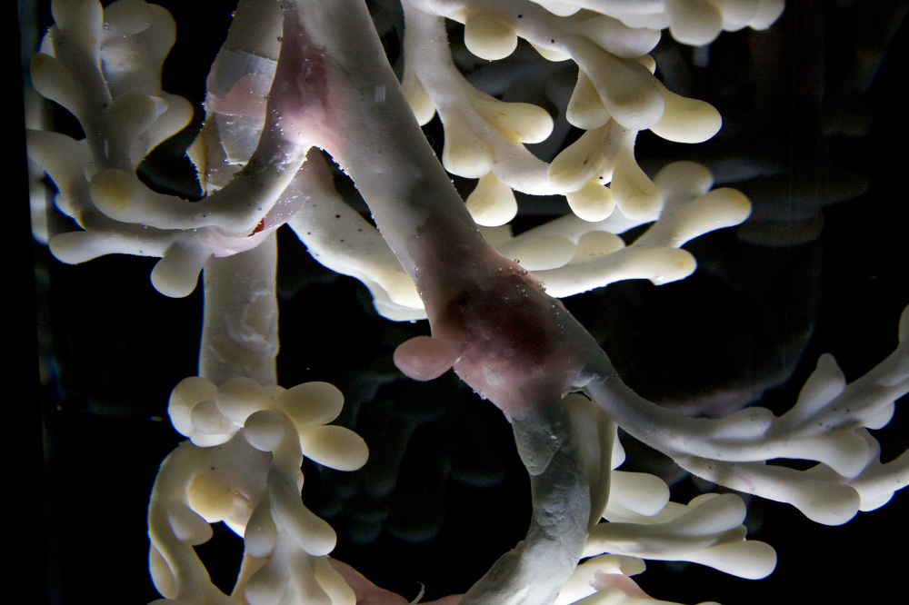

In her roles as artist, designer and scientist Pinar Yoldas takes an interdisciplinary approach to the field of biological phenomena, as well as to the use of digital technologies. She creates extensive installations, kinetic objects and film-based works focused on contemporary issues surrounding post-humanism, eco-nihilism and a feminist-oriented techno-science.
Pinar Yoldas’ speculative-design project ‘Ecosystem of Excess’ asks the question: “If life started today in our plastic debris-filled oceans, what kinds of life forms would emerge out of this contemporary primordial ooze?".
Yoldas was inspired by groundbreaking findings of new bacteria that burrow into pelagic plastics and her own research into the Great Pacific Garbage Patch, the monumental floating island of plastic waste covering somewhere between 700,000 and 15 million square kilometres. The project speculates on an alternative evolution scenario where sea animals develop organs to sense and metabolize plastics so that creatures such as pelagic insects, marine reptilia, fish and birds thrive, rather than suffer, in the toxic environments created by humans. The project imagines post-human life forms in order to expose the extreme impact that our mindless and unsustainable consumption has on the planet.
Describe your experience of the work: What are your thoughts on evolution? Is Yoldas’ idea far fetched?
What is your opinion of the piece in terms of its message, effectiveness, presentation? (Give reasons)
In what ways does the piece relate to the theme you are looking at for your exam?

