Year 9-10 Summer Work 2021
Over the Summer holiday we would like you to put your own interests and ideas at the heart of what you create. We would like you to complete the following fun tasks and bring them back to school in your first Art lesson in September!
1. Create a Visual Diary
You will be given a small sketchbook from the Art Department to work in!
As the name suggests, visual diaries are a collection of visual references compiled by an artist. Made up of notes, diagrams, collage, photography, images, and detritus, a visual diary can contain any number of materials compiled into a series of books or folders.
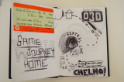
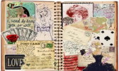
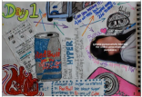
Things to put in your diary….

Your visual diary should be a visual response to your summer showing your interests….You can layout your diary in a variety of ways and also make notes about your thoughts, and experiences. It could contain:-
- Drawings using different materials of places, people, objects, etc
- Collected photos of places you have been, maps of areas, train tickets, receipts, sweet wrappers you may have eaten etc..
- Doodles of things as you think, writing in different fonts/styles, collected images from magazines/newspapers that you find or like…
- Some drawings can be quick, some more detailed, and but try to make something everyday even just for 5-10 mins!
- The options are endless but you must fill the book you have been given and create a cover.
2. Document an Exhibition visit….
Visit an Art exhibition in London and document this in your Visual Diary over 2-3 pages. Draw some of the work on display and explain what it is about and why the artist created it!
Look at this website to see what is on in London:
https://newexhibitions.com/exhibitions/region=0
Bring this work to your first lesson back after the Summer holidays. Have fun with this project- there is no right or wrong answer to this so you can create whatever you like!

