Year 11 Force

- Buy a new sketchbook for this project (cartridge paper). Create a thorough Visual Brainstorm over 2 to 3 pages in your book. Collect images (your own and from the internet and other resources) that reflect different ideas around the theme.

- Pick 5 objects that you can manipulate in different ways. Change them using your own force to distort them. You could CRUSH, TWIST, PULL, PRESS, STRETCH, SMASH etc. Take photos of each object before and after. Make detailed drawings of each object after you have changed them and try to use different materials to complete each piece. Use pencil, water colour, acrylic paint, collage, pastels, etc

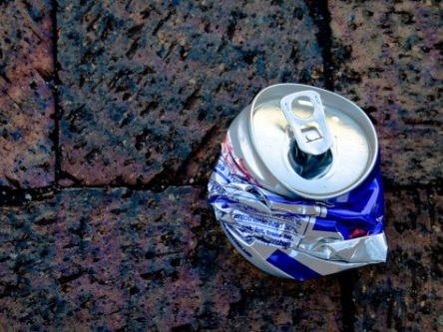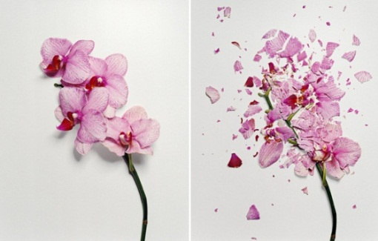

- Complete 2 pages of research on an artist of your choice. Below are some suggestions. Select one piece of work by the artist that you think could link to this theme, and analyse this in detail. What is the work called? Why did the artist create it? What is it about?
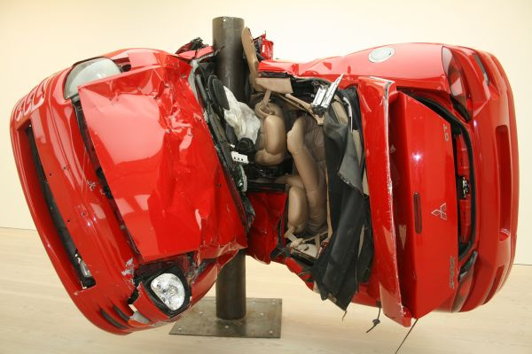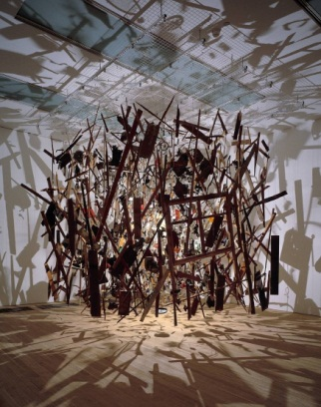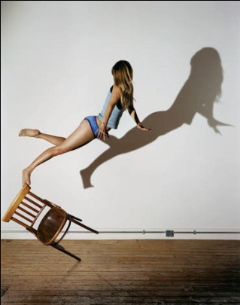
Dirk Skreber Cornelia Parker Sam Taylor Wood
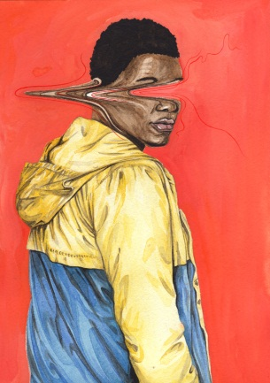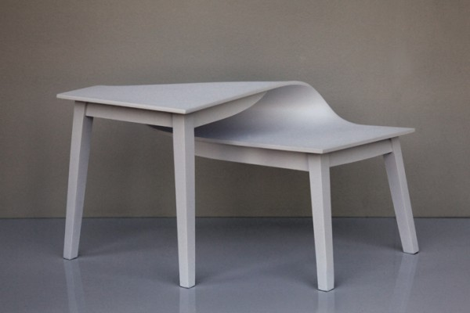
Henrietta Harris Suzy Lelievre Tadao Cern

Due in:

