GCSE Exam 2019 Reflection Half Term Tasks

- Buy a new A4 or A3 sketchbook for your Exam. Create a thorough Visual Brainstorm over 2 pages in your book. Collect images (your own and from the internet and other resources) that reflect different ideas around the theme. Read your exam paper to help you with this.

- Choose 2 tasks to complete from the following:-

- The photo below is by a photographer called Antonio Gutierrez Pereira. Take 6 different photos of yourself distorted by a reflection of some kind. This could be in the back of a spoon, through glass, water, etc. You could also set up mirrors cleverly to create strange multiple reflections. Stick these photos into your book. Make a detailed full page drawing of one of these photos.
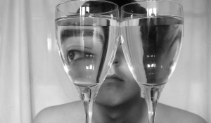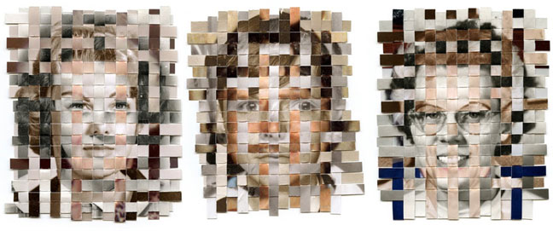
- In his series “Remnants”, Greg Sand creates a portrait made from three found photos of a single person, taken during different points of the subject’s life. Weave together 2 or 3 photos of yourself or someone you know at different points in their life. Stick the weave in your book.

- Look at the website “theburninghouse.com.” If your house suddenly caught on fire, what would you grab as you fled out the door? People are asked to group together the objects they would save from a burning building. Arrange your own objects like those below and photograph them together. Write an explanation as to why you would save these. Make detailed drawings of 3 of your objects.
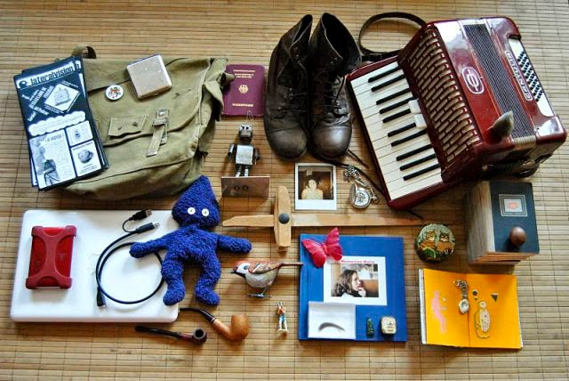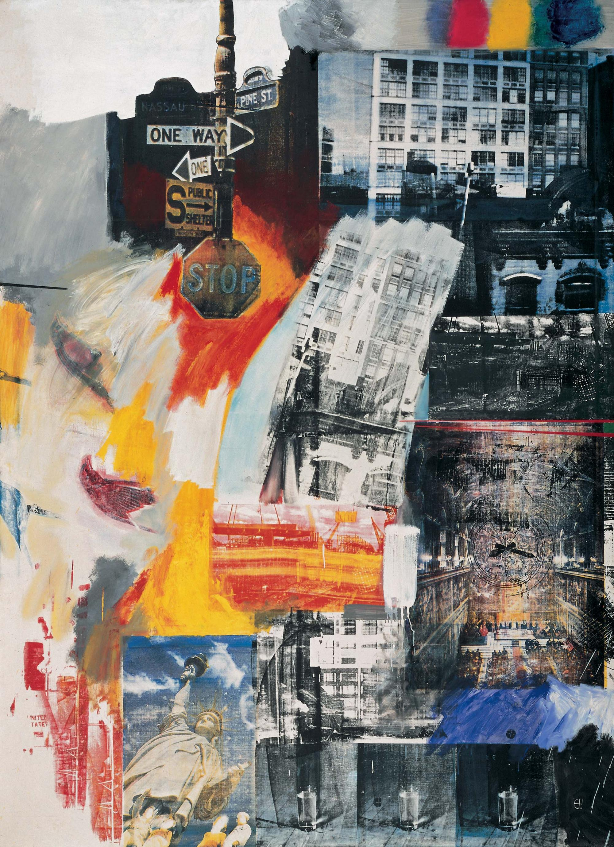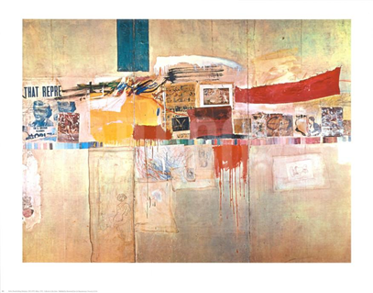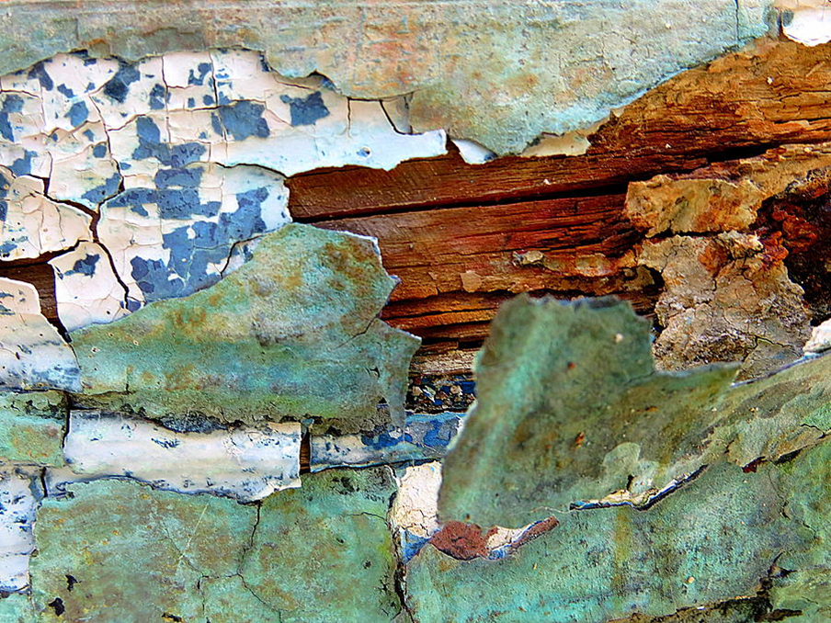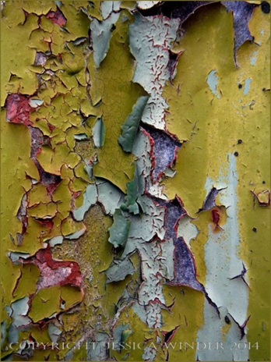
- Go on a short journey in London with a small mirror. Document small details that you pass, people you pass or people you are with, buildings, objects, signs, patterns all through the mirror! Etc. Document the journey in the following ways:
- Take 6 photos (through the mirror)
- Make 3 sketches of things you see.
- Pick up 3 things on your journey. (Receipts, a newspaper you find, a ticket from a bus or train, litter etc.).
- Now create an out of sketchbook piece in the style of Robert Rauschenberg (see above) combining lots of different elements of your journey. Include parts of photos, bits of objects, signs on your route, your thoughts on your journey (text) etc. to create a mixed media piece! You can draw and paint into this to show your personal journey in London

- Take a series of 6 photos that show layers of history like the ones above. The photos could be layers of paint, an old scratched table, an old object that has been worn in some way? Make a drawing or painting from one of these images.

- Complete 2 pages of research on an artist of your choice. Below are some suggestions and there are more in your exam paper.
Catherine Yass | Lee Friedlander | Damien Hirst | M.C. Escher
Mark Powell | Sarah Morris | Andrea Constantini | Robert Rauschenberg
Ursus Weh | Mark Quinn | Jason Martin | Victoria Reynolds

