Royal Academy:
Eco-Visionaries: Confronting a Planet in a State of Emergency

Rimini Protokoll: They are winning, 2017
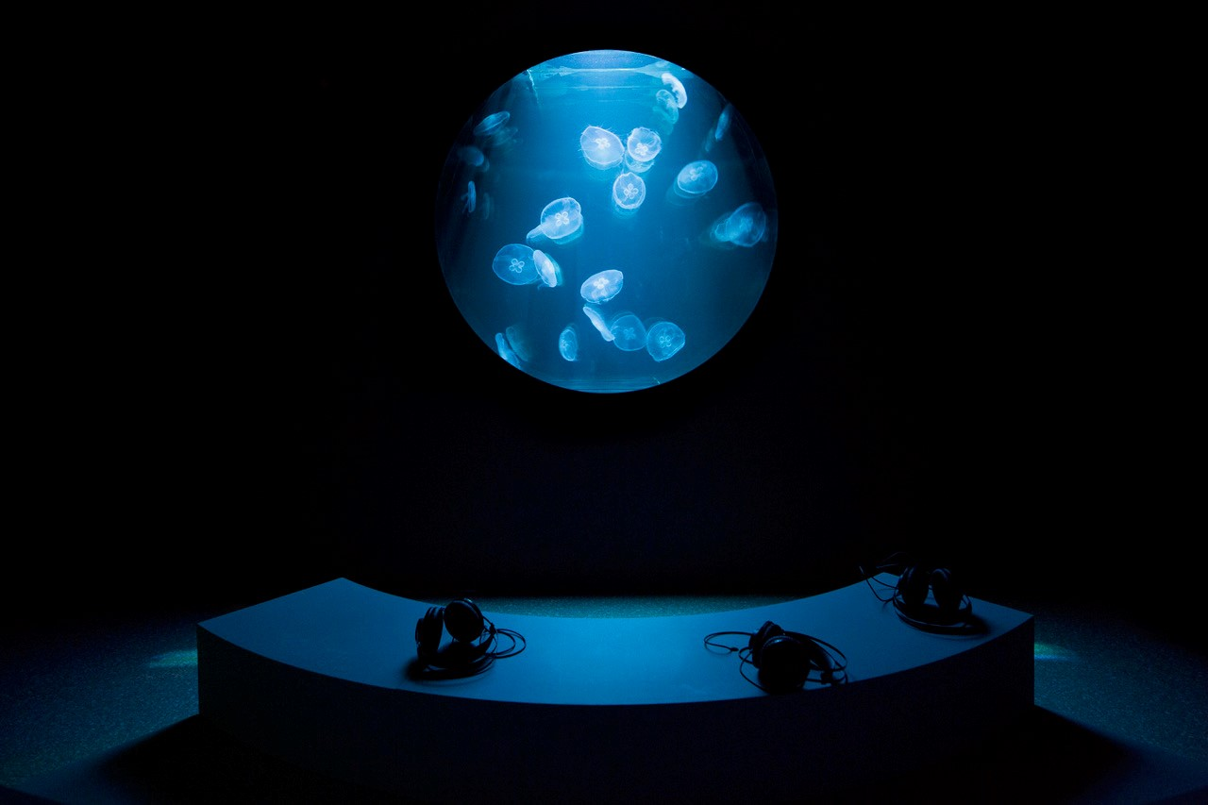
“We are in this crazy, unforeseen and incomprehensible situation where we are competing against jellyfish. And they are winning,” says the Australian marine biologist and jellyfish expert Lisa-Ann Gershwin.
For at least 670 million years, jellyfish have been floating – unchanged – through our oceans, and pretty much everything that damages our ecosystem seems to benefit them: overfishing brings down the number of predatory fish that could reduce the number of jellyfish. Plastic bags in the oceans kill other predators like turtles. On top of that, jellyfish flourish in warm water; it extends their breeding season, while many fish suffer from the lower oxygen percentage.
In the beginning of last year, a massive jellyfish invasion threatened to wipe out the fish population of the South Australian seaport Whylla, and another temporarily paralyzed the nuclear power plant in Swedish Oskarshamn when jellyfish plugged up the cooling water supply. Marine scientists have arrived at an apocalyptic prediction: “Jellyfish will be the only survivors when everything else has fallen apart.”
In collaboration with marine biologists and animal keepers, Rimini Protokoll is flipping the view of these creatures around and staging it as a gaze directed back at their observers.
Describe your experience of the work: What were you required to do? How did you feel being observed and observing others? Did you follow the instructions? Why / why not?
What is your opinion of the piece in terms of its message, effectiveness, presentation? (Give reasons)
In what ways does the piece relate to the theme you are looking at for your exam?

