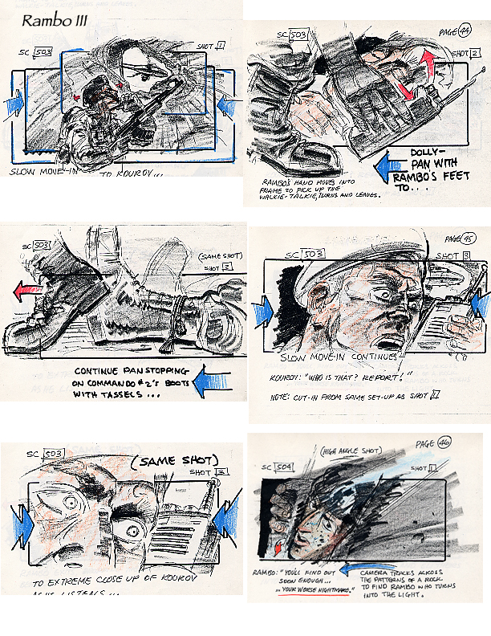
Homework: Storyboard
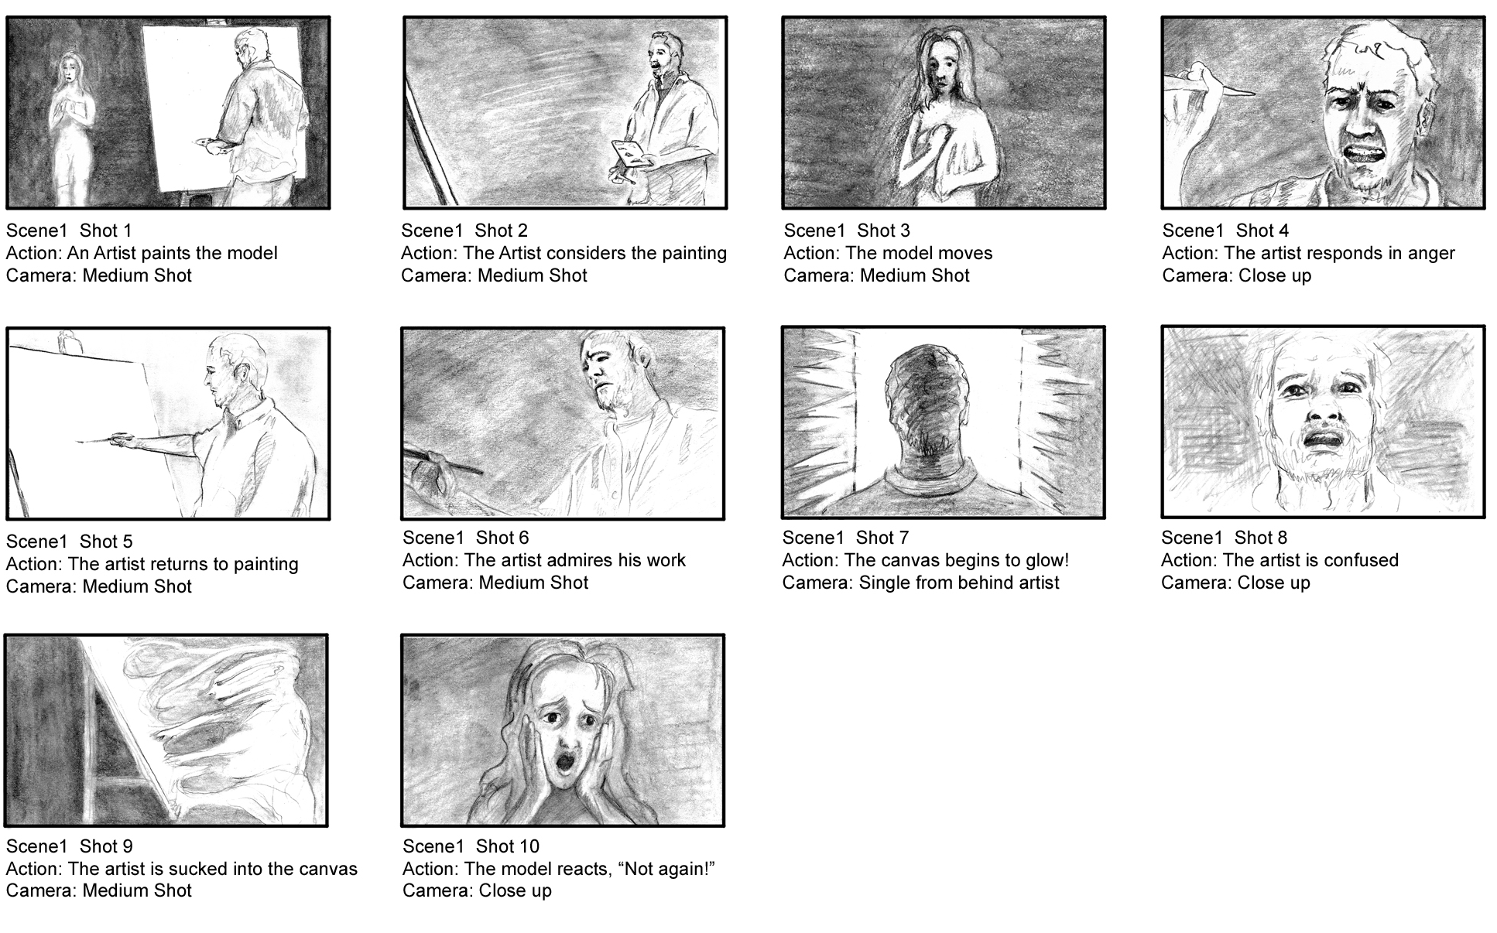
Create a storyboard that illustrates your group’s film. You may find it easier to divide the film between the members of your group. Use the proforma if it helps and draw at least 8 frames. Each frame should have notes explaining camera angles, story and direction.

<Level 5 | Level 6 | Level 7<
Make sure that your drawings show at least three different camera angles and tone to suggest the lighting. | In addition to using tone and showing different camera angles you should use marks that express the drama or movement you are trying to create. | In addition to the targets for the previous two levels you should also annotate the frames making specific reference to the 5 elements for Mise en Scene.

