Royal Academy:
Eco-Visionaries: Confronting a Planet in a State of Emergency

Tue Greenfort: Tilapia, 2017
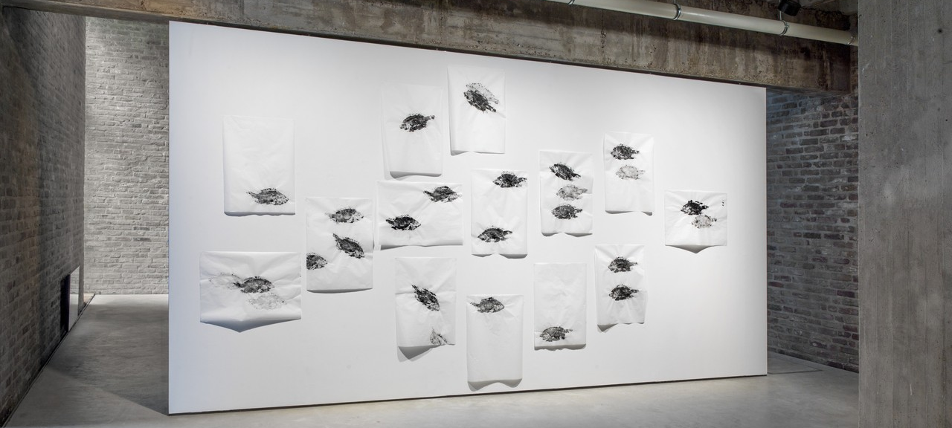
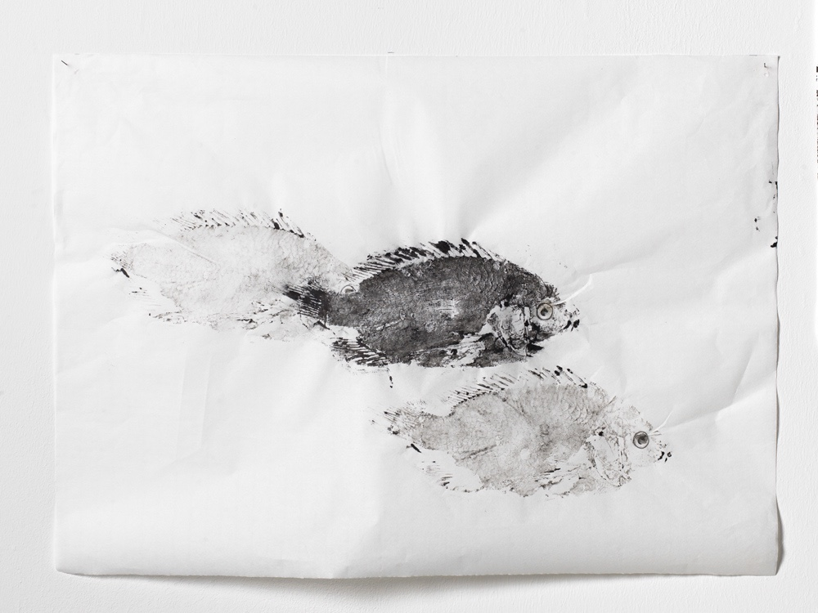
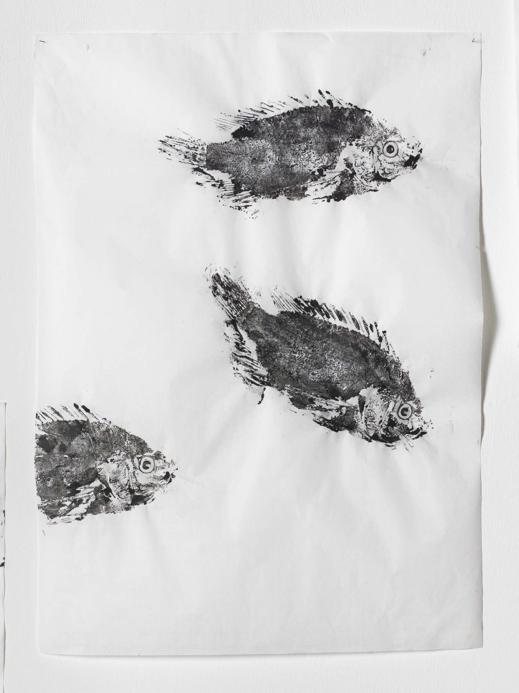
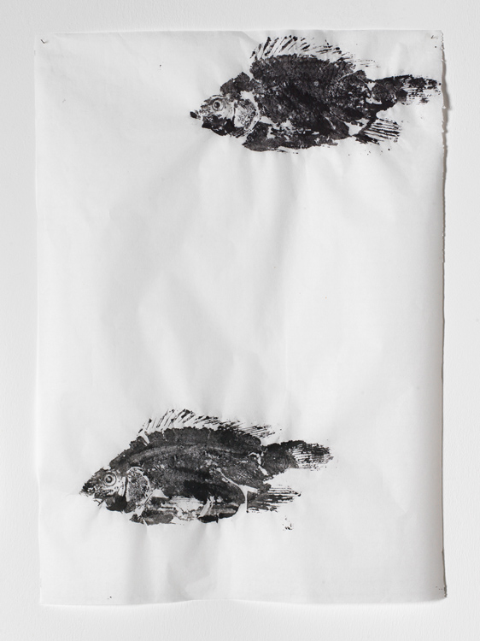
Shallow waters and coastal zones are continuously modified by men’s maritime industries. Greenfort’s work evolves around processes of the natural world, discourses of ecology and notions of the environment.
The fish Tilapia (ink on rice paper, 50x69 cm, 2017) is a living fossil. Yet, it is so less in a scientific sense than in its artistic resurrection in print: an actual 1:1 imprint of the fish’s body covered in ink on a paper made of crop, namely rice.
While the technique is usually applied for recording a fisherman’s catch, Greenfort had another idea in mind, which was sparked during the artist’s recent research at Lake Victoria in Tanzania. The lake has become infamous as the location and example of Hubert Sauper’s 2004-documentary on the fishing industry, titled Darwin’s Nightmare. Even though it’s relatively young at 400.000 years of geological age, lake Nam Lolwe (as it is called in Northern Tanzania’s native language Luo) is has a delicate kinship: While some species of the Tilapia fish are endemic to the lake, some others introduced in the 1950s are invasive and predatory, causing the complete disappearance of the former, and many others – and ultimately of the lake’s entire environmental equilibrium. The dramatic dynamics of life and death at stake come to the fore in Greenfort’s black-and-white display of fish on the brink of fossilization.
Describe your experience of the work: What was the overall impression of the fish as they were arranged on the wall?
What is your opinion of the piece in terms of its message, effectiveness, presentation? (Give reasons)
In what ways does the piece relate to the theme you are looking at for your exam?

