[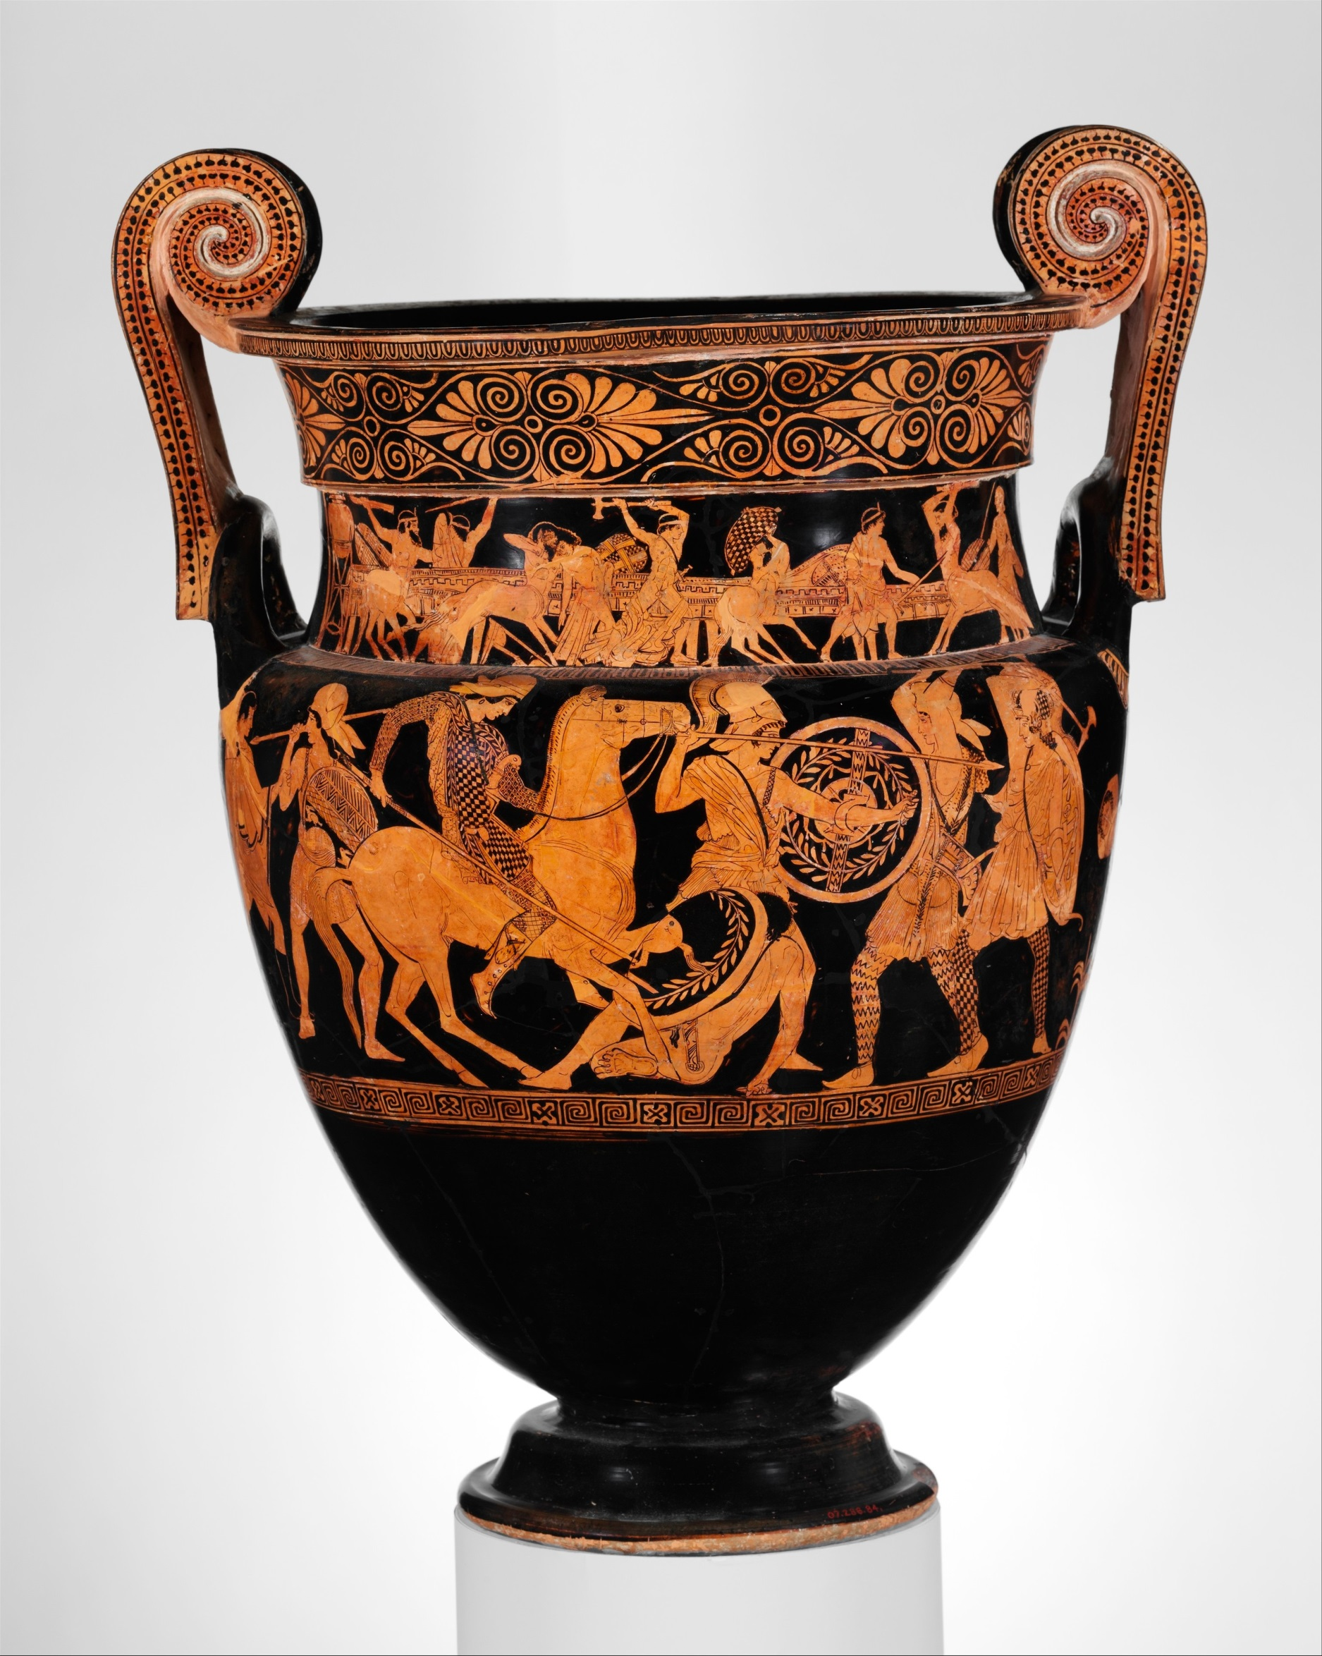](https://www.google.co.uk/url?sa=i&rct=j&q=&esrc=s&source=images&cd=&cad=rja&uact=8&ved=0ahUKEwjy09a0ibTZAhXELcAKHZl2AHkQjRwIBw&url=https://www.metmuseum.org/art/collection/search/247964&psig=AOvVaw38TLL2yqQJKlMndGkFBd7C&ust=1519201555962023)