[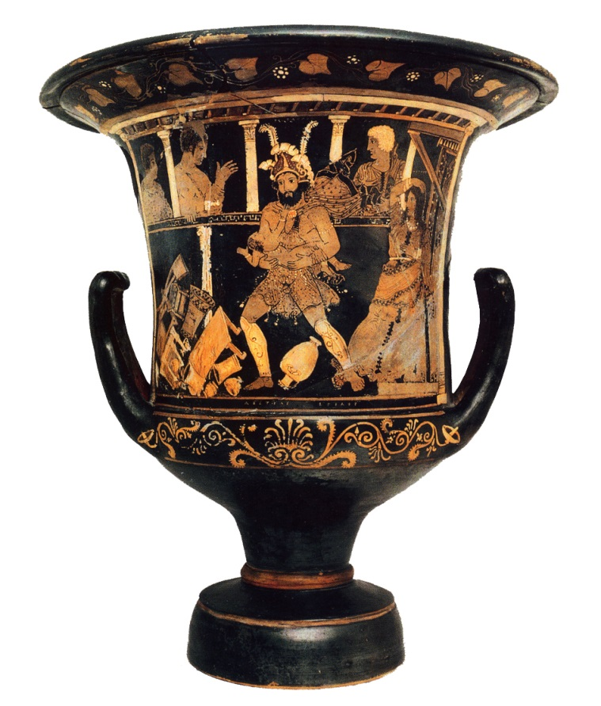](http://www.cvaonline.org/tools/pottery/painters/keypieces/paestan/asteas.htm)