Royal Academy:
Eco-Visionaries: Confronting a Planet in a State of Emergency

Dunne & Raby: Designs for an Overpopulated Planet, 2009
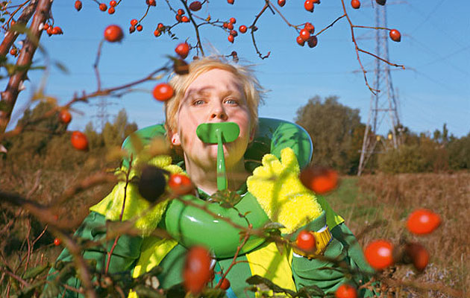
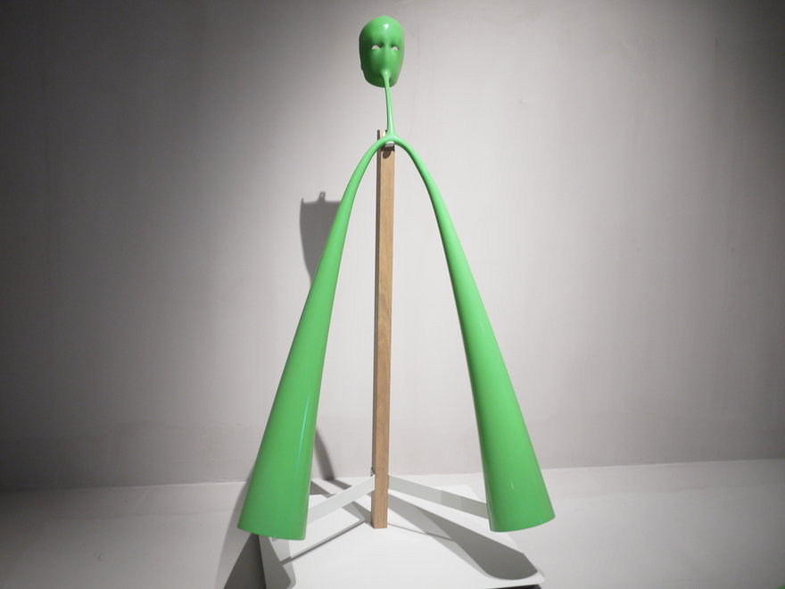
Do you know about gizzards," asks Anthony Dunne excitedly. Luckily the question is rhetorical and the answer comes with the next breath. "The gizzard is an organ in a bird that can literally grind metal down to nothing. They will often eat a pin or a paper clip by accident and this organ just grinds it."
This is just one of many nuggets that Dunne and his partner Fiona Raby, of design duo Dunne & Raby (Icon 022), have come across in the research for the studio's latest project, Foragers.Foragers looks at how humans could extract nutritional value from non-human foods by using a combination of synthetic biology and new digestive devices inspired by other mammals, birds, fish and insects. "We are outgrowing our species," says Dunne. "In 2050 the world's population will be 9 billion. If we want to keep on overpopulating, not change our attitudes and consume like crazy, maybe genetic engineering is the only way forward?"
Foraging has romantic connotations of searching for food in the wild, but Dunne & Raby's foragers are genetically reconfigured human beings that go at nature with full force, trying to process trees, cellulose and plant matter as nutrition. The four Foragers objects are rather fantastical though. The grass processor is the most disturbing – it's a facemask connected to long arm extensions that reach the ground where it is supposed to suck up nutrition from grass and weeds.
Describe your experience of the work: What are your thoughts on evolution? Are Dunne and Raby’s idea far fetched?
What is your opinion of the piece in terms of its message, effectiveness, presentation? (Give reasons)
In what ways does the piece relate to the theme you are looking at for your exam?

