Class Task 2: Pushing the Limits of Photography

What do you need to photograph?
Photograph empty spaces around the school. Your teacher will have a list of empty classrooms but also consider the halls, toilets, kitchen, offices, corridors and outside spaces that appear redundant when there are no people in them.
Consider wide shots as well as details- is there any evidence of the people who usually inhabit these places.

Expectation 1: Focus
Photograph both natural and man made subject matter.
- Make sure that your camera is on MANUAL FOCUS.
- Photograph the same subject several times, altering the focus each time so that you can make comparisons on your weebly later.
- Explore depth of field (AV / Aperture priority on your camera)
- Include movement and / or zoom blur.

Expectation 2: Composition
- Select a composition that has the main subject o the periphery of the frame
- Brutally crop your subject

Expectation 3: Exposure
- Make sure that your camera is on MANUAL
- Preset your shutter speed and aperture. (eg.1/60 & f8)
- Set your white balance to daylight
- Set up your composition.
- Focus (this should be on Manual too- MF)
- Photograph the same composition, changing your ISO each time (eg. 100, 200, 400, 800 etc)
- Observe how the exposure changes.
- Make a note of your observations.

TIP
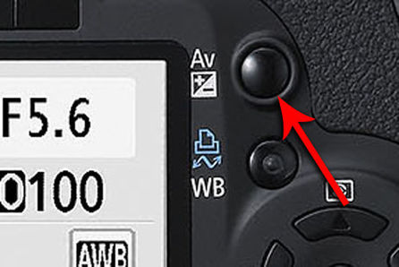
The Aperture/Exposure Compensation Button has 2 functions.
- Aperture Selector: to set the aperture (on Manual mode), hold down this button and turn the dial to the preferred aperture.
- Exposure Compensation: used to alter the standard exposure set by the camera. You can make the image under or or over exposed with this function, and it can be used in any creative shooting mode (apart from Manual).

- Use the Exposure Compensate Button to over and under expose your images (not in Manual mode)

Post Production
Expectation 3: Exposure
Use the threshold function to alter the contrast of your image.

Expectation 4:
Chemical
Burning
Painting
Stitching

Make sure that your intentions are clear for each after effect. What impact does the technique you choose have on the message / appearance / mood / atmosphere….

