PERFORMANCE CALCULATOR | Level 1 |  |  | Level 2 |  |  | Level 3 |  |  | Level 4 |  |  | Level 5 |  |  | Level 6
A LEVEL PRACTICAL  – OCT 2015 | LIMITED ABILITY |  |  | BASIC ABILITY |  |  | EMERGING COMPETENT ABILITY |  |  | COMPETENT AND CONSISTENT ABILITY |  |  | CONFIDENT AND ASSURED ABILITY |  |  | EXCEPTIONAL ABILITY
Taxonomy | partial, inconsistent, literal, elementary, minimal, rushed, sporadic, naïve, lacks skills, little creative intent, disjointed, pedestrian, credible, worthy  Link to visual exemplars |  |  | straightforward, deliberate, just adequate, methodical, superficial, unrefined, lacks understanding and focus, crude visual language, simplistic reflection, weak connections, plays safe, unresolved  Link to visual exemplars |  |  | predictable, broadening, makes progress, relevant, description not explanation, demonstrates intentions, appropriate, sufficient, control, emerging individuality, thorough, developing skills, adequate, lacks perception, signs of understanding  Link to visual exemplars |  |  | diverse, effective, purposeful, consistent, skilful, coherent, imaginative, informed, some perception, satisfies creative intent, engaged  Link to visual exemplars |  |  | independent, realised, sensitive, creative, sustained, highly inventive, critical, perceptive, comprehensive, in-depth, insightful, original, genuine creative journey, refined, highly skilled, in-depth reflection, pertinent connections, exciting  Link to visual exemplars |  |  | inspired, surprising, unique, authoritative, genuine discovery, adventurous, accepting of the unexpected, challenging, synthesis of ideas, fully informed, questioning, sophisticated, dexterous, fluent skills, erudite, intuitive, daring  Link to visual exemplars
AO1  Develop ideas through sustained and focused investigations informed by contextual and other sources, demonstrating analytical and critical understanding  (embraces analysis and articulation) | 1 | 2 | 3 | 4 | 5 | 6 | 7 | 8 | 9 | 10 | 11 | 12 | 13 | 14 | 15 | 16 | 17 | 18 | AO1 total:
 | LIMITED |  |  | BASIC |  |  | EMERGING COMPETENT |  |  | COMPETENT AND CONSISTENT |  |  | CONFIDENT AND ASSURED |  |  | EXCEPTIONAL
AO2  Explore and select appropriate resources, media, materials, techniques and processes, reviewing and refining ideas as work develops  (embraces practical exploration and manipulation) | 1 | 2 | 3 | 4 | 5 | 6 | 7 | 8 | 9 | 10 | 11 | 12 | 13 | 14 | 15 | 16 | 17 | 18 | AO2 total:
 | LIMITED |  |  | BASIC |  |  | EMERGING COMPETENT |  |  | COMPETENT AND CONSISTENT |  |  | CONFIDENT AND ASSURED |  |  | EXCEPTIONAL
AO3  Record ideas, observations and insights relevant to intentions, reflecting critically on work and progress  (embraces recording and control over the formal elements) | 1 | 2 | 3 | 4 | 5 | 6 | 7 | 8 | 9 | 10 | 11 | 12 | 13 | 14 | 15 | 16 | 17 | 18 | AO3 total:
 | LIMITED |  |  | BASIC |  |  | EMERGING COMPETENT |  |  | COMPETENT AND CONSISTENT |  |  | CONFIDENT AND ASSURED |  |  | EXCEPTIONAL
AO4  Present a personal and meaningful response that realises intentions and, where appropriate, makes connections between visual and other elements  (embraces outcomes/responses with connections to sources) | 1 | 2 | 3 | 4 | 5 | 6 | 7 | 8 | 9 | 10 | 11 | 12 | 13 | 14 | 15 | 16 | 17 | 18 | AO4 total:
 | LIMITED |  |  | BASIC |  |  | EMERGING COMPETENT |  |  | COMPETENT AND CONSISTENT |  |  | CONFIDENT AND ASSURED |  |  | EXCEPTIONAL
 |  |  |  |  |  |  |  |  |  |  |  |  |  |  |  |  |  |  | Total mark:
Using the performance calculators
All AS and A level student work should be marked using the assessment grids in the accredited specifications.
The performance calculators are a support tool to help you make accurate judgements about student work. There are three performance calculators:
- One for assessing A level practical work and written annotation
- One for assessing A level personal study
- One for assessing AS practical work and written annotation
Step by step instructions
- Choose the relevant performance calculator.
- Take each Assessment Objective (AO) in turn.
- Follow the AO across the chart (from left to right) until the work exhibits characteristics reflected in the taxonomies in the levels from 1 to 6.
- Choose those taxonomy words that apply to the work (not all of them will) and write them in the appropriate box(es) on the performance calculator.
- Writing the taxonomy words in the relevant boxes will give you a clear visual picture (like a graph) of the student’s performance for each AO (see the worked example below).
- At any time, look at real student work that has been marked by our senior examiners. You can access real student work for each level by clicking on the Link to visual exemplars within the electronic versions of these performance calculators.
- Circle the mark awarded or write the mark awarded in the far right-hand column.
A worked example
In AO1, an A level student may show superficial development and their analysis of other artists' work may be unrefined. They may show a lack of understanding, with simplistic reflection and unresolved connections to their resources. This would place this student firmly in the middle of Level 2 BASIC ABILITY. The student is solidly in this level, and would receive 5 marks for AO1.
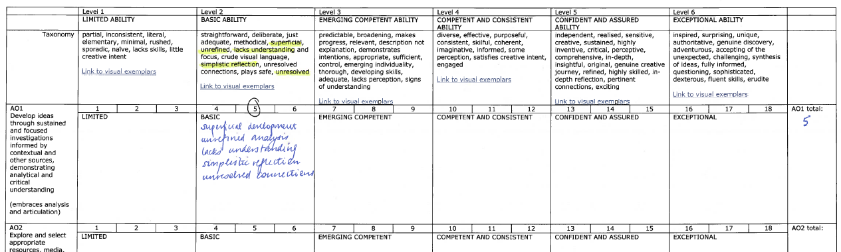
This same student might be showing broadening understanding of some of their contextual references. ‘Broadening’ is in the taxonomy of Level 3 EMERGING COMPETENT ABILITY. The fact that ‘broadening’ applies to the work pushes the student towards the next level. This would place the student at the top of Level 2 EMERGING COMPETENT ABILITY so the student would receive 6 marks for AO1.
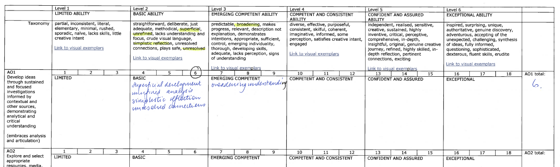

If the student achieves even more words in the higher level, they may need to cross the boundary into Level 3 EMERGING COMPETENT ABILITY, and receive 7 marks for AO1.

