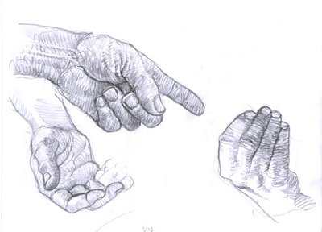
Year 10
Draw your hands in 3 different positions (one hand per page).Take your time and complete with full tonal shading using 2B or 4B pencils

