Diane Arbus Identical Twins, 1967
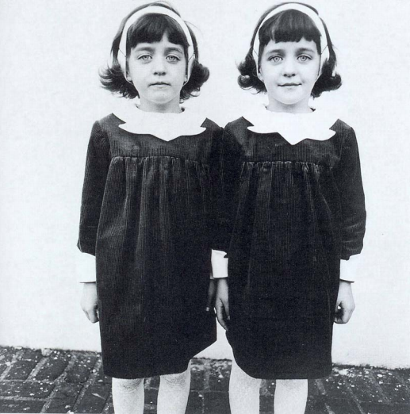

Denotative | Connotative

Diane Arbus A Family on Their Lawn One Sunday in Westchester, New York, 1969
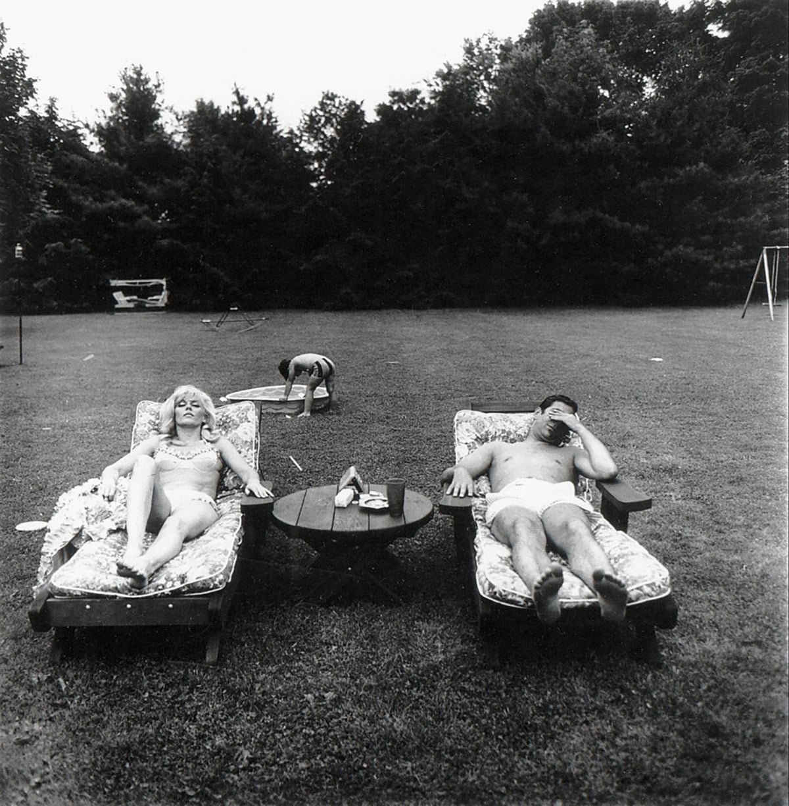

Denotative | Connotative

