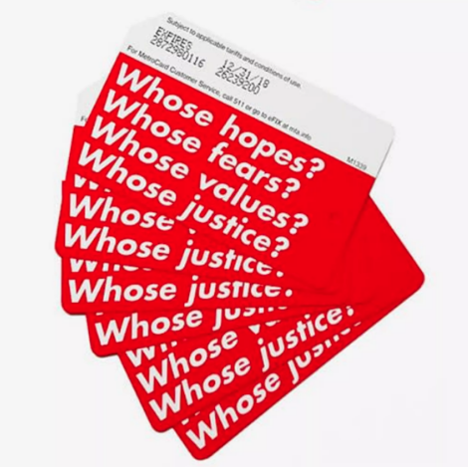
Barbara Krugar

Watch the clip and answer these questions…

Where does the style of writing that Krugar uses come from?

Why does she like working with fonts? What does she feel it gives to her work?

Where does she find the images she uses?

Why does she use red?

What two values in her work does Krugar think are still relevant today?

What does she want her work to do?

Answer these questions about the piece, ‘Your Body is a Battleground’ 1989

Why did Krugar make this piece?

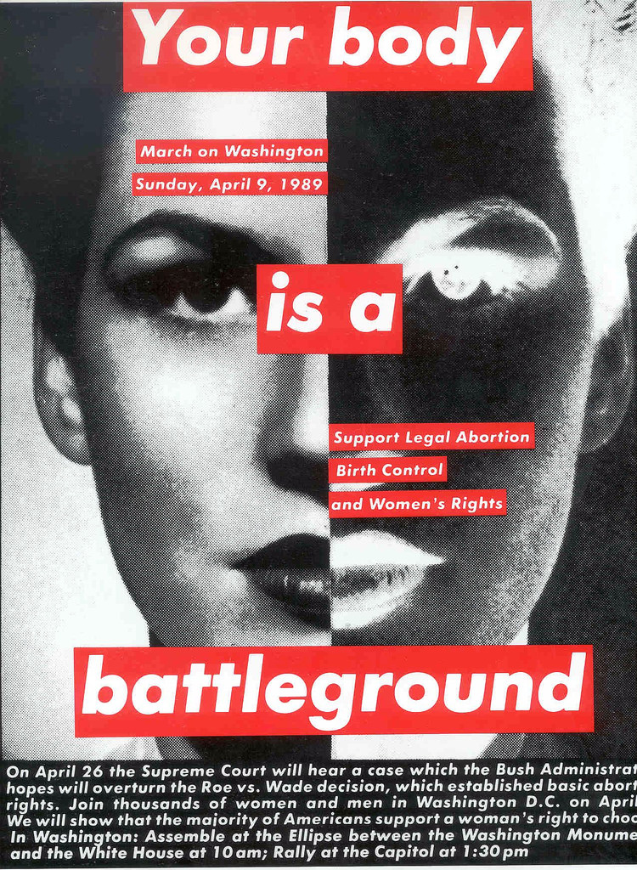
What was the march for?

Where did she present the image?

Why wouldn’t this have had the same impact if she had put the work in a gallery?

What is happening in America today?

The Trump administration has expanded its ban on funding for groups that conduct abortions or advocate abortion rights, known as the global gag rule.

Although this policy does not directly affect services in the US, Mr Trump has said he supports an abortion ban at home.

On the presidential campaign trail, he said he believed "some form of punishment" should be in place for women who have abortions, if the practice is banned.

Learn these words…
Tabloid: A tabloid is a newspaper that has small pages, short articles, and lots of photographs. Tabloids are often considered to be less serious than other newspapers.
San serif: A category of typefaces that do not use serifs, small lines at the ends of characters. Times is a serif font for example.

