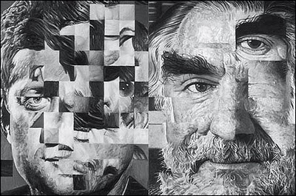
JIM SHAW
Jim Shaw is an American artist who has created distorted drawings of himself and famous people . He does this by first cutting into photos and chopping them up to rearrange them. He then makes new photo collages from these, and then works from this new image to create hyper-real , yet twisted portraits .Some are symbolic depictions—such as that of Ronald Reagan whose face is literally haunted by figures from the American culture of violence (Charles Manson, Rambo, etc.)—and Hollywood subjects. We thus rediscover the stylistic and anthropological range of the approach of Jim Shaw, that formidable reader of his country’s popular culture, from which he extracts perverse scenarios with a disquieting realism.
Born 1952 in Midland, Michigan, Jim Shaw lives and works in Los Angeles.
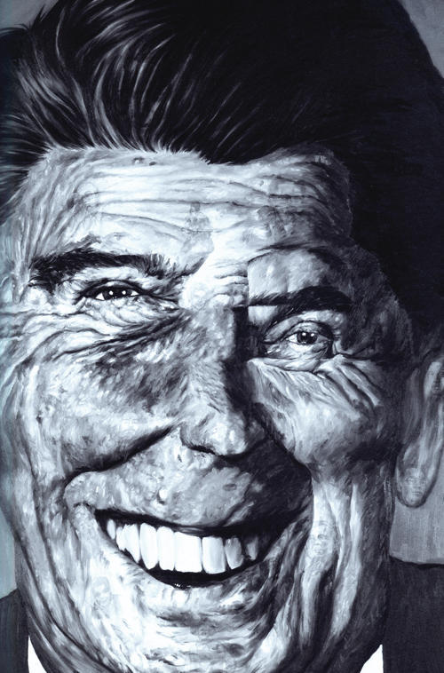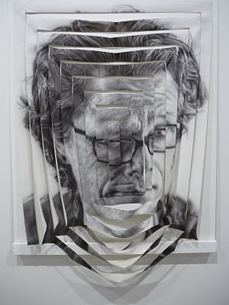
- Print off 2 images of a celebrity A4 size. Stick one of the images into your sketchbook. Chop the other one into pieces /shapes/squares and put back together as a mixed collage. Stick this in your book.
- Make a detailed drawing/painting of your new mixed and distorted celebrity collage in your sketchbook.
- Stick in these images of Jim Shaw’s work into your sketchbook . Find out some information on Jim Shaw –how does he create these pieces and why? You can also use the information above but put this in your own words and present this in your sketchbook.

