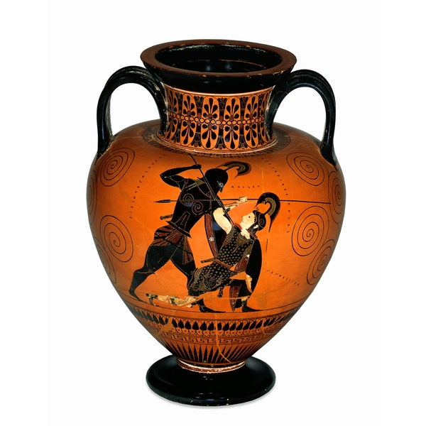
Black-figured amphora (wine-jar) signed by Exekias as potter and attributed to him as painter 540-530 BC

