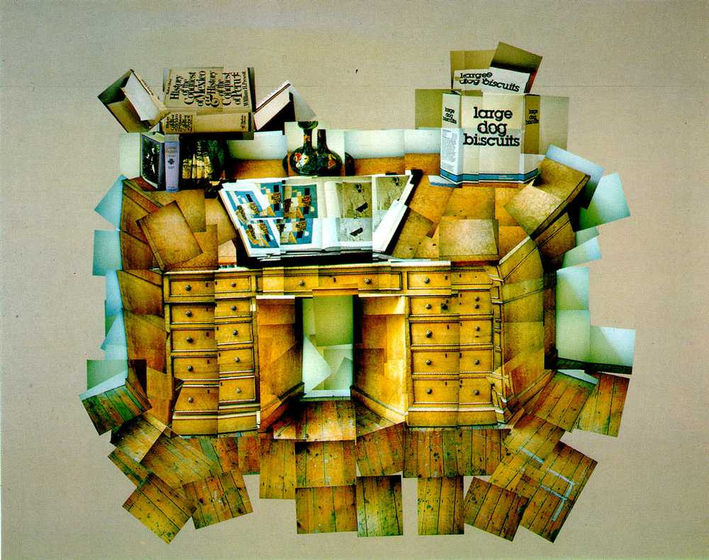
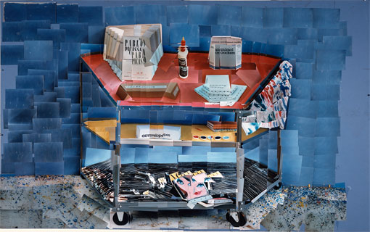
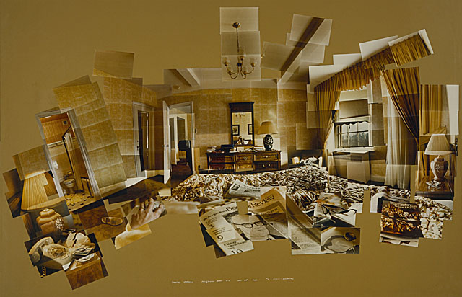
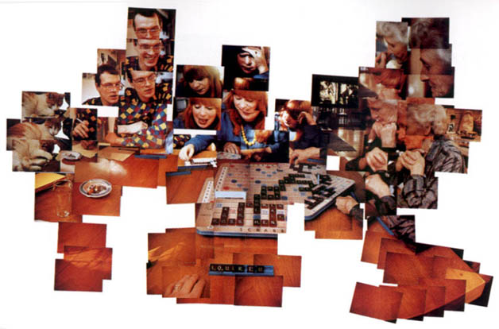
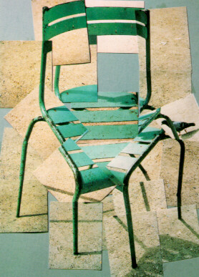
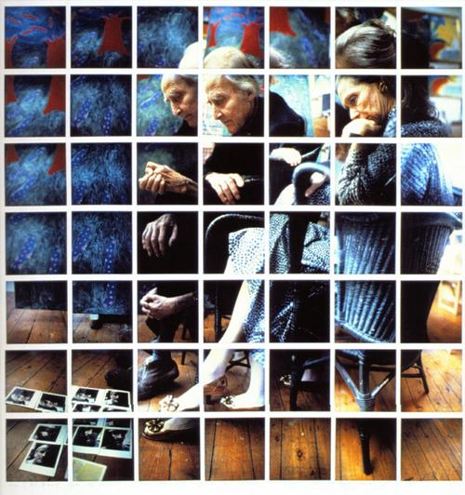
David Hockney Analysis help sheet.

EASY
Complete this gap filling exercise:
David Hockney is connected to the __________ (Pop Art, Impressionist, Vorticist) art movement. This movement was interested in responding to ___________ ( Portraiture, Popular Culture, Poverty)
Hockney has also created ___________ (installation, a cookbook, photomontages). Photographs are taken from different perspectives and at slightly
different times of the same object. The images are then ___________ (collaged, painted, burned) to recreate the place, person or object even though they may look distorted. This work connects with the ___________ (Futurist, Abstract Expressionist, Cubist) movement, which was one of Hockney's major aims.
Hockney called them "joiners”.
Copy this into your weebly and illustrate it with pictures of images of his domestic object joiners.

MEDIUM
Discuss the photomontages created by Hockney between 1970-86. You should mention his inspiration and connections to Cubism.
What was his aim?
How did he achieve this?
How does this work connect to your classwork.

ADVANCED
Complete the ‘Medium’ tasks and examine the connection between Picasso and David Hockney’s photomontage. How similar are their intentions?

PRACTICAL:
- Compose a photo with a strong centre of interest. Since you are taking pictures of a very wide area, you should keep your centre of interest very close.
- Make sure your camera is correctly focused for each shot.
- Remember, never to move from your spot until you’re done. You may tilt the camera up and down during the shoot, but never change your shooting position.
- Practice shooting first. The idea behind Hockney’s approach is to photograph a large scene by breaking it up into many smaller ones. You must think of your scene as having an invisible grid with overlapping squares placed upon it. Begin shooting with only your waist turned three-quarters to the left. Continue to shoot your first horizontal row of photos, remembering to always overlap the photo you just took, until you reach a position where your waist is turned three-quarters to the right.
- Begin to shoot the second row of horizontal photos as you did previously, but you must also overlap the top of this row with the bottom of the last row.
- Continue to shoot the entire scene always overlapping both vertically and horizontally until you complete the scene.
- Either edit your images together using Photoshop or a similar piece of
software or print your images separately and cut and stick them together.

USEFUL WEBSITES
http://www.hockneypictures.com/home.php
http://vimeo.com/25314669

